AML TRANSACTION & FRAUD ANALYSIS DASHBOARD

Project Report

Submitted By:Jaseera
Tool Used: Microsoft Power BI Desktop

Introduction
For this project, I developed an AML Transaction and Fraud Analysis Dashboard using Microsoft Power BI. The main purpose of this dashboard is to analyse financial transactions and identify possible fraudulent activities.
Money laundering and fraudulent transactions are major challenges in the financial sector. Banks and financial institutions need to monitor transactions regularly to identify unusual activities and reduce financial risks.
Using Power BI, I converted transaction data into an interactive dashboard with different charts, KPI cards and filters. It helps users understand transaction patterns, monitor fraud status and analyse different types of fraud alerts.

2. Objectives
The main objectives of this project are:
- To analyse financial transactions using Power BI.
- To identify and monitor fraudulent transactions.
- To compare fraudulent and non-fraudulent transactions.
- To analyse transaction activities across different timestamps.
- To understand different alert types.
- To monitor the total number of transactions and accounts.
- To present transaction information through an interactive dashboard.

3. Dataset Description
The project uses transaction-related data for analysing financial activities and detecting possible fraud.
The dashboard includes the following fields:
- Timestamp: Represents the time or sequence of transaction activities.
- Alert ID: Unique identification number assigned to a fraud alert.
- Alert Type: Represents different types of transaction alerts, such as Cycle and Fan-in.
- Is Fraud: Indicates whether a transaction is classified as fraudulent or non-fraudulent.
- Account Details: Information used for analysing the accounts involved in transactions.
These fields help in understanding transaction patterns and identifying possible suspicious activities.

4. Data Preparation
Data preparation is an important step before creating a dashboard. The transaction dataset needs to be checked and organised so that it can be used correctly in Power BI.
The data preparation process includes:
- Importing the dataset into Power BI Desktop.
- Checking the available columns and their data types.
- Identifying the transaction, account and fraud-related fields.
- Checking missing or blank values.
- Ensuring that numerical and categorical fields are suitable for analysis.
- Preparing the data for creating charts and KPI cards.
Note: The exact Power Query transformations need to be confirmed from the Power BI project file.

5. DAX Measures Used
DAX (Data Analysis Expressions) is a formula language used in Power BI to perform calculations and create measures.
In this project, KPI cards are used to display important transaction information, such as:
- Total Transaction Amount
- Total Accounts
- Fraudulent Transactions
- Total Transactions
These measures help users understand the overall transaction performance quickly.
The exact DAX formulas can be added after checking the measures in the Power BI file.

6. Dashboard Components
The AML Transaction and Fraud Analysis Dashboard contains different visualisations to analyse financial transaction activities.

6.1 KPI Cards
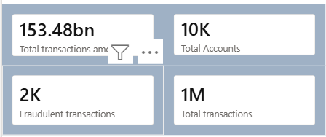
The dashboard contains four KPI cards to display important information.
- Total Transactions Amount: Displays the overall transaction amount, shown as 16.78K.
- Total Accounts: Displays the number of accounts, shown as 10K.
- Fraudulent Transactions: Displays the number of fraudulent transactions, shown as 2K.
- Total Transactions: Displays the total transaction count, shown as 2K.
These cards provide a quick summary of the important transaction details.

6.2 Fraudulent Transaction Volume Across Timestamp
A line chart is used to display fraudulent transaction volume across different timestamps.
It helps users understand how transaction activities change over time. It also helps identify periods where transaction activity increases or decreases.
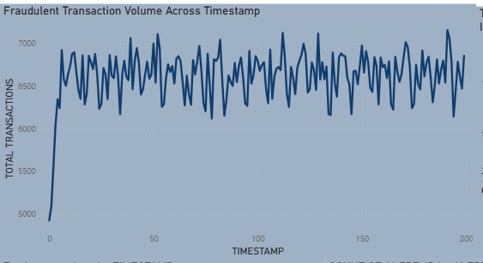

6.3 Total Transactions
A doughnut chart is used to represent the total transactions.
It provides a simple visual representation of transaction information and helps users understand the overall transaction distribution.
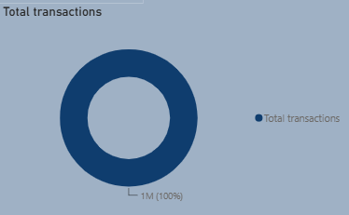

6.4 Fraud Status
A slicer is provided to filter the dashboard based on fraud status.
It contains two options:
- True – Fraudulent transactions.
- False – Non-fraudulent transactions.
This helps users focus on a particular transaction category and analyse the results separately.
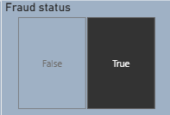

6.5 Alert Type
An Alert Type slicer is used to filter transactions based on different alert categories.
The dashboard includes:
- Cycle
- Fan-in
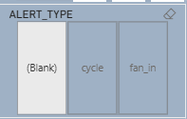
This helps users analyse different alert categories and understand the type of transaction activities being monitored.

6.6 Total Transactions by Timestamp
A line chart is used to show the total number of transactions across timestamps.
It helps users understand transaction activity over time and identify changes in transaction volume.
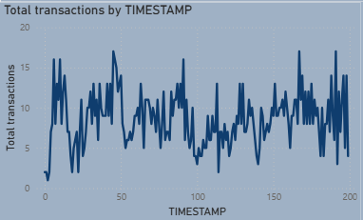

6.7 Count of Alert ID by Alert Type
A horizontal bar chart is used to compare the number of alerts under different alert types.
It displays the count of Alert IDs for Cycle and Fan-in categories. This helps users identify which alert category has a higher number of alerts.
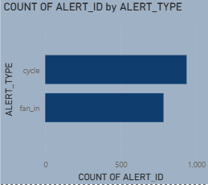

6.8 Total Transactions Amount by Is_Fraud
A column chart is used to compare transaction amounts based on fraud status.
It helps users understand the transaction amount associated with fraudulent and non-fraudulent categories.
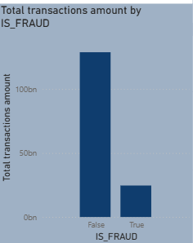

7. Slicers Used
Slicers make the dashboard interactive and allow users to filter information.
The following slicers are used:
- Fraud Status: Filters the dashboard based on True or False.
- Alert Type: Filters the dashboard based on Cycle, Fan-in and Blank categories.
These slicers help users analyse specific transaction categories without changing the original dataset.

8. Key Findings
After analysing the dashboard, the following observations can be made:
- The dashboard displays a total transaction amount of 16.78K.
- The total number of accounts displayed is 10K.
- The fraudulent transaction KPI displays 2K.
- The total transactions KPI displays 2K.
- Transaction activities show variations across different timestamps.
- Cycle and Fan-in are the two main alert categories displayed in the bar chart.
- Fraud status filtering helps separate fraudulent and non-fraudulent transaction information.
- The alert type chart helps compare the number of alerts under different categories.
These observations help in understanding transaction activities and monitoring possible fraudulent behaviour.

9. Conclusion
Working on this project helped me understand how Microsoft Power BI can be used to analyse financial transactions and monitor possible fraudulent activities.
By creating KPI cards, line charts, bar charts and slicers, I was able to present transaction information in a simple and understandable way.
This project also helped me understand the importance of AML analysis in the financial sector. Identifying suspicious transactions and monitoring different alert categories can support banks and financial institutions in managing fraud-related risks.
Overall, this project improved my knowledge of Power BI, data visualisation and financial transaction analysis.

10. References
- Microsoft Power BI Desktop
- AML Transaction and Fraud Analysis Dataset
- Microsoft Power BI Documentation

